Assignment 13

1.
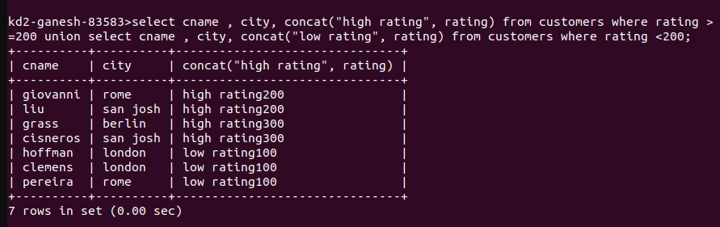

2.
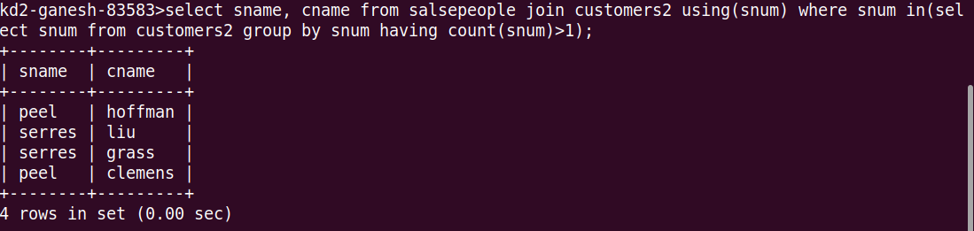

3..
